People are “living control systems.” That includes employees and their managers. Organizations are filled with living control systems – and with the non-human kind as well (e.g., rules, regulations, standards, policies, etc.). Collisions are inevitable and unavoidable.
When control systems collide, there is conflict to be managed – and it must be managed by the living control systems involved – managers and employees.
Control systems collide because they are attempting to control the same variable but to different standards. The boss wants Joe to stay late but Joe is determined to attend his son’s birthday party. Joe and his boss are both trying to control same variable – Joe’s whereabouts at a certain time. Joe has a higher goal – he wants to enjoy his son’s birthday party and he wants his son to know that Joe loves him and thinks he is important. Joe’s boss has a higher goal, too; getting an important piece of work finished in time to meet tomorrow morning’s deadline.
So how do these two colliding control systems manage the conflict to which they are both parties?
The honest answer is that it depends; it depends on Joe, his manager, their priorities, their relationship, and probably some other factors as well. Some thoughts relevant to managing conflict between colliding control systems follow.
- Take it up a level. First and most important, recognize that living control systems have a hierarchical control system, which is to say that controlling a given variable (Joe’s whereabouts) contributes to the control of some higher-level variable. For Joe, it’s enjoying his son’s birthday party and contributing to his son’s happiness. For Joe’s boss, it’s completing some unfinished work, meeting a deadline, and performing well. So, Joe and his boss should not bog down over the conflict about Joe’s whereabouts; instead, they should go up a level to see why both are trying to control Joe’s whereabouts. Indeed, it might prove necessary to go up more than one level. Doing so establishes the context for the conflict and makes clear to both parties the reasons they are trying to control the variable at the center of the conflict.
- Search for alternatives. With the context clear, a search for alternatives is the next step. Joe might suggest that he could return to work after his son’s birthday party and work into the evening to finish up the work. Joe’s boss might suggest that Joe bring his son to work tomorrow and the boss will hold a party for the boy at work. If Joe isn’t the only one who can complete the work in question, they might look for someone else to finish up the work. They might even look at extending the deadline. There are numerous possibilities.
- Avoid unilateral resolution. It is tempting, if you’re a boss, to tell Joe he has to stay late or else. It might be tempting, if you’re Joe, to tell the boss to shove it. Both are unilateral resolutions, and neither is likely to turn out well. If the boss pushes, Joe might quit and, if he’s the only one who can do the work the boss has made matters worse. If Joe tells the boss to shove it, he might get fired, demoted, reassigned or any one of a number of unpleasant consequence the boss might impose.
- Don’t focus on the presenting conflict. Finally, in keeping with the first point above, don’t get hung up on the presenting conflict; in this case, Joe’s whereabouts. Always take it up at least one level and perhaps more until you have established a clear and comprehensive context for the presenting conflict, one that enables both parties to see, understand and appreciate where the other party is coming from and why the variable at the center of the conflict matters.
To illustrate all this graphically, depicted below is a basic control loop. At the top is the desired value for the controlled variable. The controlled variable is affected by the actions of the control system and by other, independent effects. The control system monitors the actual value of the controlled variable and compares it with the desired value. If an unacceptable discrepancy occurs, the system acts to correct it.
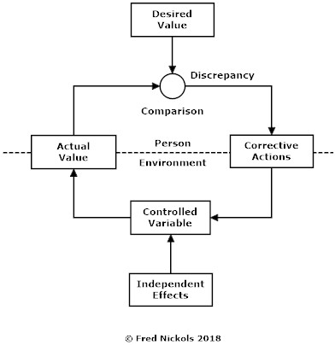
Now, imagine the control system is Joe, the living control system we discussed earlier. One of Joe’s controlled variables is his whereabouts at the time of his son’s birthday party after normal working hours. Imagine another living control system, Joe’s boss. One of his controlled variables is also Joe’s whereabouts after normal working hours. Joe wants to be at his son’s party; Joe’s boss wants him to stay late. Joe and his boss are both trying to control the same variable – Joe’s whereabouts – albeit for different reasons and to different ends.
When control systems collide, it is essential to be clear about those different reasons and different ends. Only when those are clear to both parties to the conflict is successful resolution likely. Can Joe’s boss pressure Joe into staying late? Maybe, maybe not. Can Joe ignore his boss’ requirement? Maybe, maybe not. But only when both are clear about the context in which the conflict is occurring and the higher aims and ends of the other can they collaborate in successfully resolving the conflict.

Further Reading
Readers interested in learning more about living control systems, conflict arising from different systems attempting to control the same variable but to different values, hierarchical control, and how to “go up a level,” are encouraged to obtain and read Controlling People by Richard Marken and Tim Carey (2015). Australian Academic Press: Samford Valley, Australia.
For a collection of papers dealing with “living control systems,” see Living Control Systems: Selected Papers of William T. Powers (1989). The Control Systems Group, Inc.: Gravel Switch, Kentucky.

