**The Circumplex Model of Emotion**

In psychology, the term affect, or affective state, is generally used to refer to all types of subjective experiences that are valenced, that is, experiences that involve a perceived goodness or badness, pleasantness or unpleasantness. In experimental research, valence is traditionally used as a bipolar dimension to describe and differentiate between affective states (e.g., Bradley & Lang, 1994; Plutchik, 1980; Wundt, 1905). Russell (1980, 2003) introduced the concept of ‘core affect’ by combining the affect dimension with physiological arousal into a circular two-dimensional model. According to Russell, the experience of core affect is a single integral blend of those two dimensions, describable as a position on the circumplex structure in Figure 1. The horizontal axis represents valence (from unpleasant to pleasant), and the vertical axis represents arousal (from calm to excitement). The various positions on the circumplex structure are illustrated with examples of affective responses that can be experienced in the user-product interaction.

Figure 1. Circumplex model of core affect with product relevant emotions (Desmet, 2007; adapted from Russell, 1980).

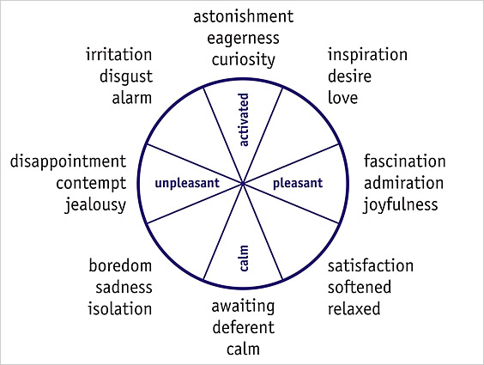

We constantly experience core affect: from the moment we wake up to the moment we fall asleep, our core affect moves about in Figure 1, responding to a wide variety of internal (e.g., hormonal changes, nutritional deficiencies) and external causes (e.g., events, people, objects, weather). Core affect can be neutral (the central point), moderate, or extreme (the periphery). Changes can be short lived or long lasting, and can be in the focus of attention (in the case of intense core affect), or a part of the background of a person’s experience (in the case of mild core affect).

Core affect theory offers a simple, yet powerful, way to organize product experience, because all possible experiences involved in the user-product interaction can be described in terms of core affect. The activated unpleasantness from the heated irritation in response to a failing computer, the calm pleasantness from the soothing experience of sliding into a warm bath, the activated pleasantness from the exhilaration of ice skating, and the calm unpleasantness from the sadness in remembering a broken crystal vase, can all be plotted on the circumplex model.

Source: <http://www.ijdesign.org/ojs/index.php/ijdesign/article/view/66/15>