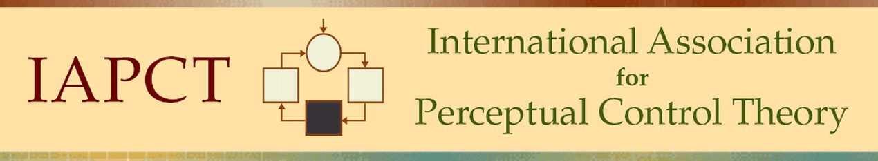
Formerly the Control Systems Group

28th Conference of the IAPCT

October 11-13, 2018

Northwestern University, Evanston, Illinois, USA

Thursday, 11 October

9:00 am to 3:30 pm Explore William T. Powers Archives at Northwestern University

4:00 to 4:50 pm IAPCT Board Meeting

5:00 to 6:00 pm Annual Meeting

6:00 to 7:30 pm Dinner

7:30 – 9:00 pm Reception

Friday, 12 October

8:30 to 9:00 am Registration

9:00 to 10:15 am Opening Session

Welcome and Introductions

In Memoriam Recognition –Led by Lloyd Klinedinst

An Introduction to Living Control Systems -- Dag Forssell

10:15 to 10:30 am Break

10:30 to 12:00 Rubber Bands and Tennis Balls: Portable Demonstrations of Perceptual
Control -- Gary A. Cziko

Limitless PCT? Building an Evidence Base for Applying PCT to
Phobias, Psychosis, Dementia, and Violent Extremism; And Broadening Scope to Groups, Families, Schools, Prisons and Community Settings, Warren Mansell (via Skype)

12:00 to 1:00 Lunch

1:00 to 3:00 pm How to Study Living Control Systems -- Richard Marken

Neural Basis of PCT -- Henry Yin

3:15 to 3:30 pm Break

3:30 to 5:00 pm When Control Goes Wrong: Social Problems from a Control Theory
Perspective -- Kent McClelland

Panel and Open Discussion: PCT Research Priorities and Needs – Heather Broccard-Bell, Henry Yin, and Rick Marken

6:00 onwards Dinner and Social

Saturday, 13 October

8:30 to 9:00 am Registration

9:00 to 10:15 am Militarism, Machismo, and the Regulation of Self-Image -- Brian
D’Agostino

Can We Control the Behavior of Others or Only Influence It? PCT, Interpersonal and Other Perspectives -- Richard Pfau

10:15 to 10:30 am Break

10:30 to 12:00 Robotics the Natural Way: Dodging the Computational Approach --
Rupert Young

12:00 to 1:00 Lunch

1:00 to 3:00 pm Collective Control of Foraging in Honey Bee Colonies -- Heather Bell

Language as the Control of Perception -- Bruce Nevin

My Body Through PCT Glasses – Dag Forssell

3:15 to 3:30 pm Break

3:30 to 5:00 pm PCT Transforms Teaching: A Presentation and Panel Discussion --
Lloyd Klinedinst

Panel and Open Discussion: Promoting PCT -- Dag Forssell, Lloyd Klinedinst, and Rupert Young

6:00 onwards Dinner and Social

Updated: 24 July 2018

